BLHS 150 Making and Creating: The Moral Craft of Life

Spring 2022
Monday 5:20-7:50pm
Online zoom classroom

Professor Michael Kessler, Department of Government, Law Center, and Berkley Center
mjk62@georgetown.edu

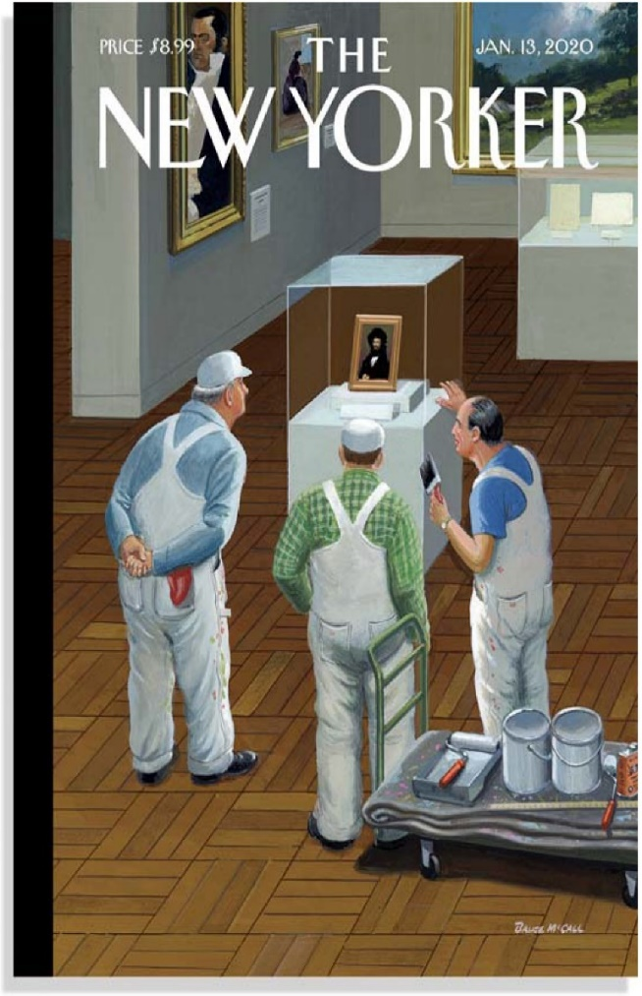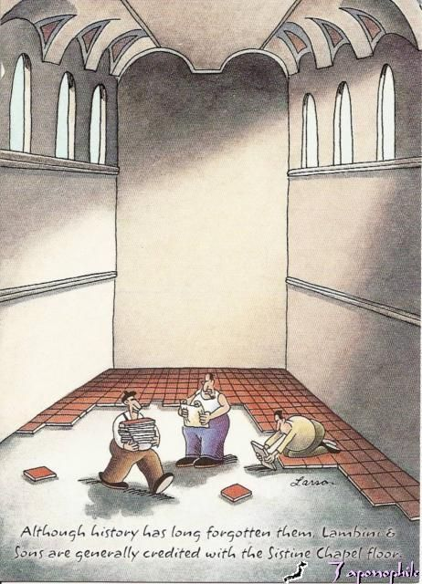
BRUCE MCCALL'S "A BRUSH Far Side, Gary Larson
WITH GREATNESS"

Humans have made and created things for their subsistence, their use, their enjoyment, and their fulfillment for millennia. We build the things we need for life and we also create meaning and express value in and through that making and creating. How we think about our skills and creative capacities, and how we cultivate them and to what ends we deploy them, are primary ways in which we consider and shape how we ought to live. Human creativity is, fundamentally, a moral activity, involving choice, expression of earthly (and divine) goods, and pursues what we hold dear as our ultimate concerns.

This Ignatius Seminar explores philosophical and theological visions of craft, labor, and creativity, and their connections to moral and political life, as a way to think about how our laboring, crafting, and creating is a fundamental part of what constitutes the good life.

We will consider many questions about creativity, technology, and the meaning of life. Here are some of them:
- What are humans capable of making and creating?
- What is “craft” and “craftsmanship” and how is it distinct from “art” (see the New Yorker cover above: why is the “painting” in the museum case “great” while the painting craft of the workers not notable enough to be marked off and preserved?”)?
- How does craft “make” the craftsperson, as a person, as a member of a community, as a creator?
- What ought we do with our skills, goals, and capacities and what responsibility do we bear for how and what we make?
- How do capacities to create and make (crafts, tools, technology, things, cultures, homes, art, food, political institutions, ourselves) create meaning and value?
- What are the demands upon creativity: is there a natural or transcendental goal to our making or is it pure utility and convention?
- What guides craft, as a skilled kind of work—(reason? Inspiration? “genius?” tradition? Utility?).
- How do natural constraints of materials, physics, design limits, etc. impose upon the craft process and is part of excellence in craft the ability to tweak and push those limits?
- What are the dangers to our making?
- What is the temporal meaning of creating artifacts and tools in a fluctuating, dynamic world (if they are not durable, what’s the point of making them well; why not disposability)? What are the theological implications?
- How do politics and policy shape the possibility of craft and creativity?
- How are creating and self-reliance a mode of politics?
- How do economic practices impinge upon this creativity?
- How does craft create practices that become norms and expectations? How does craft create communities?
- How does technology, industrialization, and economic value shape, enhance, or diminish “craft”? Can craft be restored in late capitalist modes of production?
- How do we (and should we) value “craft” and skilled work as a society?

This seminar will explore human creativity as a moral and political activity through close reading of a number of philosophical and theological thinkers, including Aristotle, Gregory of Nyssa, Aquinas, Locke, Nietzsche, Marx, Arendt, Thoreau, Adorno and Horkheimer, Heidegger, Paul Tillich, Wendell Berry, Matthew Crawford, among others who have thought specifically about craft in a particular area of skilled wisdom, such as cooking, building, woodworking, and gardening. We will also have a variety of “field” experiences, including the opportunities to meet and discuss these ideas with makers in our community—builders and chefs, among others.

The course will be conducted mostly through discussion and in-depth analysis of the assigned readings. Students should be prepared to participate actively, based on a thoughtful reading of the texts.

What it means that this class is liberal arts seminar
As a liberal arts eminar, this course draws on the educational insights of St. Ignatius of Loyola, founder of the Jesuits, in seeking to cultivate the Ignatian ideal of cura personalis: care for each person’s individuality and care for his or her integral wholeness. It seeks to educate the whole person—mind, body, and spirit—by not only conveying information and intellectual content, but seeking to enrich all dimensions of students’ lives. Accordingly, we take an integrative and personal approach to learning in Ignatius seminars, seeking to cultivate a variety of intellectual and moral virtues as we study and analyze texts and practices from diverse cultures and traditions together.

As a liberal arts seminar, the course is a real opportunity for you to learn some of the skills of being a university student at a rigorous educational institution. I will be guiding you through some acquisition of understanding about how academic study and disciplines work, about careful reading and interpretation of texts, about critical analysis of ideas and arguments, and about respectful—but probing and insistent—dialogue with others (both your colleagues and the texts and authors we encounter). We will be doing that regarding a topic about which you may not have a full sense of the interlocking issues.
Explore!
Be curious!
Take a risk by opening a new view of the world and others!
Do that and you will learn something about an important set of issues, and about yourself, and be ready for the rest of your Georgetown journey.

Expectations and Assignments
- You should strive to achieve the ideals of a liberal arts education: free and candid exchange of ideas, rigorous critique of claims, and toleration for patiently and fairly considering variant positions.
- Thoughtful reading of the texts in preparation for the class is expected and essential.
- Students should be prepared to participate actively in each week’s seminar discussions. Participation in class is worth 15% of your grade. You are expected to discuss and analyze the arguments of particular texts. I will take note of students who do well, poorly, or are not adequately prepared for class. To receive the full credit for class participation, you do not need to ask ‘correct’ questions or comment brilliantly in all circumstances; rather, the credit will be received when it is clear that you made a good faith attempt to read and comprehend the material and can ask reasonable questions and comment adequately about the material.
- “Actively participate in the class and avoid doing other tasks on your computer that are not class related!” You may use your laptop computers in class for note-taking, for looking up relevant items on the web related to class issues, for referring to related class readings, and for group work. Other non-class uses of laptops during class time are unacceptable.
- You must adhere to the principles of conduct set forth in the Georgetown University Honor System unconditionally. I assume you have read the honor code material located at www.georgetown.edu/honor, and in particular have read the following documents: Honor Council Pamphlet, “What is Plagiarism?”, “Sanctioning Guidelines”, and “Expedited Sanctioning Process.”
  - Submitting material in fulfillment of the requirements of this course means that you have abided by the Georgetown honor pledge:
    - In the pursuit of the high ideals and rigorous standards of academic life, I commit myself to respect and uphold the Georgetown Honor System: To be honest in any academic endeavor, and to conduct myself honorably, as a responsible member of the Georgetown community, as we live and work together.
  - Any sign of violations, including plagiarism, dishonesty, or cheating will be referred to the Honor Council and your Dean(s).
  - Any incident of plagiarism will constitute a failure in the assignment and zero credit for that portion of the grade. More severe sanctions may be administered by the Honor Council.

- Attend the class sessions. If you have a legitimate excuse, I need to know it (by email). Legitimate excuses include illness, family situation, or other events or responsibilities that may occasionally draw you away from a regular class meeting. To be legitimate, I need to know about it beforehand, or it may be deemed legitimate if I receive a notice from your dean, in the case of more serious issues.
  - Attendance will be recorded at each class.
  - Excused absences do not yield a grade penalty, although I reserve the right to impose reasonable “make-up” meetings or assignments to ensure that the covered material is satisfactorily understood.
  - You will be penalized for unexcused absences. Penalties for unexcused absences will involve grade reductions for each unexcused absence.

- Formal Papers (60% total)
  - A substantial portion of your grade (60%) will consist in writing multiple papers.
    - One 3-page paper due during the semester (12.5%)
    - One 3-4 page paper based on an interview of a maker/creator (12.5%)
    - A 10 page final paper due at the end of the term (35%)
  - Papers should be submitted on Canvas. Papers should be submitted on time, or they will receive a late penalty. Be sure to talk to the professor before the due date if you have a problem and wish to request an extension.
  - There will be no late papers accepted past the final semester deadline without a legitimate excuse from your school’s Dean’s office. Failure to complete the final assignment on time will constitute a failure of the course.
  - Topics for the papers will be assigned, with some flexibility for selecting among a set of questions. The final paper will be mostly based on class readings and the topic will be worked out with the professor.
  - Details about the interview assignment will be given in class. You will identify a maker, develop questions to ask them based on our class readings and discussions, and write up an analysis of it for submission.

- Class Session preparation (15% total)
  - Each class will have assigned texts. A major goal is to understand the specific arguments made by the authors, and to critically relate them to other positions we are considering.
  - In advance of each class (starting with the second), by noon of the day of class, please post a critical discussion on the discussion board for the week’s class (there will be one discussion forum for each class session).
  - Your post will be public for other members of the class to read.
  - Select one text to critically examine a claim/claims the author makes. Or, select a particular issue and discuss the different ways two or more authors take divergent views on that issue. First, you should make sure you understand, in the best light possible, the argument the author(s) is making. Lay out the claims and discuss how they are justified (is there sufficient evidence? Are counter-arguments adequately accounted for?). Then provide an argument for how you judge the position (with whom do you agree and why?). The posting should be about the equivalent of about ¾ of a typed page single spaced.

- Grades: The grading scale for the course will be:
A 94-100% C+ 78-79
A- 90-93 C 74-77
B+ 88-89 C- 70-73
B 84-87 D 60-69
B- 80-83 F 59 and under

Office Hours

Office hour times: I am available many times throughout the week for individual or group meetings. Please simply schedule it by email. I will also post a regular time for meeting.

Course Materials:

The seminar will involve close textual readings and discussion. Students are expected to attend class with the readings (to refer to, to make arguments from). Most of the readings are excerpts and selections and are available either online or they will be made available on the Canvas site for the course. The following books are available for purchase via the bookstore (or Amazon):

Glenn Adamson, The Craft Reader, Berg, 2007, 9781847883049
Richard Sennett, The Craftsman, Yale, 2009, 9780300151190
Matthew Crawford, Shop Craft as Soulcraft, Penguin, 2009, 9780143117469
Wendell Berry, The Unsettling of America, Ingram, 2016, 9781619025998
Hannah Arendt, The Human Condition, University of Chicago Press, 2018, 9780226586601
Schedule
Week 1 (January 12 (Wednesday)): Introduction—Laying Some Groundwork about Craft and Life
        - Homer, Iliad, Book 18 (lines 368-616)
        - Peter Korn, Why We Make Things and Why it Matters, 49-68
        - Tara Brown, “The Death Of Shop Class And America's Skilled Workforce”
        - Richard M. Ebeling, “The Rise of Capitalism and the Dignity of Labor,” (blog post)

Week 2-3 (January 24/31): Theories of Making and Creating
        - Techne, not episteme: Aristotle Eudemian Ethics Bks I and II, Nichomachean Ethics, Book VI; Metaphysics, Book V (selections)
        - Rational Hands: Gregory of Nyssa On the Making of Man
        - Active and Contemplative Life: Thomas Aquinas, Summa Theologica (selections)
        - Medieval and Renaissance guilds handout
        - Craft within Determining Factors: Anni Albers, “On Weaving,” in The Craft Reader
        - Wise Power: Alexander Langlands, “Defining Craft,” in Craft
        - Craft as a Way of Doing, Well-Done: Otto Salomon, “‘Introductory Remarks’ From the Teacher’s Handbook of Slöjd” (in The Craft Reader)

Art or Craft or Something Else?
        - Kant, Critique of Judgment (selections)
        - R.G. Collingwood, The Principles of Art (selections in The Craft Reader)
        - John Bentley Mays, “‘Comment’ and Responses,” (in The Craft Reader)
        - Malcolm McCullough, “Abstracting Craft: The Practiced Digital Hand,” (in The Craft Reader)

Week 4-5 (Feb 7/14): Models of Creation, Work, Creativity
        - Martin Luther, (selections on “vocation”)
        - Pope Leo XIII, Rerum Novarum (selections)
        - Jonathan Malesic, “Why we need a new theology of work”
        - Richard Sennett, The Craftsman (selections)
        - Hannah Arendt, The Human Condition (Chapters 3-4, selections)
        - John Ruskin, “Modern Manufacture and Design” and “The Nature of the Gothic” (in The Craft Reader)
        - David Pye, The Nature and Art of Workmanship, (selections)
        - Michele Hardy, “Feminism, Crafts, and Knowledge” in Objects and Meaning: New Perspectives on Art and Craft

Paper #1 due Friday February 19

Week 6 (Feb. 22 (Tuesday)) Creating, Labor, and Alienation
        - Adam Smith, (selection from Volf, “Adam Smith’s Understanding of Work”)
        - Karl Marx, selections from Economic and Philosophical Manuscripts, and “Wage, Labour, and Capital” and “Capital” (in The Craft Reader)
        - Friedrich Engels, The Condition of the Working Class in England (selections)
        - Harry Braverman, “The Primary Effects of Scientific Management” (in The Craft Reader)
        - Thomas Carlyle, “Midas,” “Labour,” “Happy,” “Religion,” “Reward,” and “Chartism” (selections)
        - Hannah Arendt, The Human Condition (selections)

Week 7 (Feb. 28): Consumption and Production
        - Frank Trentmann, The Empire of Things (selections)
        - Lizabeth Cohen, A Consumer’s Republic (selections)
        - Ruth Schwartz Cowan, More Work for Mother (selections)

Rejecting Industrial Production and a Return to Craft: The Arts & Craft Movement and Stickley Furniture
        - Thomas James Cobden-Sanderson, “The Arts and Crafts Movement” (speech)
        - William Morris, “The Revival of Handicraft,” (in The Craft Reader)
        - Ellen Gates Starr, “Art and Labor,” (in The Craft Reader)
        - Selections from:
          - The Arts and Crafts Movement in America 1876-1916
          - Smith and Vertikoff, Greene & Greene Masterworks
          - The Rise of Everyday Design: The Arts and Crafts Movement in Britain and America
          - Cathers and Vertikoff, Stickley Style in the Craftsman Tradition

Week 8 (Mar. 14): Thinking and Being as a Craftsperson
        - Matthew Crawford, Shop Class as Soulcraft (selections)
        - Richard Sennett, The Craftsman (selections)
        - “Why I Build” and “Keeping Craft Alive” selections from Fine Homebuilding
        - M.C. Richards, “Centering,” (in The Craft Reader)
        - Eudorah Moore, “Craftsman Lifestyle” (in The Craft Reader)
        - Sara Berry, “From Peasant to Artisan, Motor Mechanics in a Nigerian Town,” (in The Craft Reader)

Week 9 (March 21): The Craft of Food—Agriculture and Local Community
        - Deborah Fitzgerald, Every Farm a Factory, (selections)
        - Belasco and Horowitz, Food Chains: From Farmyard to Shopping Cart, (selections)
        - Geoff Andrews, The Slow Food Story, (selections)
        - Wendell Berry, selections from his Agrarian essays including Home Economics, Another Turn of the Crank, What are People For?, Farming: a Hand Book, and The Unsettling of America

Week 10 (March 28): The Craft of Food—Cuisine and Cooking
        - Richard Olney, Simple French Food, (selections)
        - Tom Colicchio, The Craft of Cooking, (selections)
        - Anthony Bourdain, Kitchen Confidential, (selections)
        - Susan Terrio, “Crafting Grand Cru Chocolates” (in The Craft Reader)
        - Background Episode of Chef’s Table

Week 11 (April 4): The Craft of Woodworking
        - Sam Maloof, Woodworker, (selections)
        - George Nakashima, The Soul of a Tree: A Woodworker’s Reflections, (selections)
        - Michael Pekovich, The Why and How of Woodworking, (selections)
        - Graham Blackburn, “A Guide to Good Design,” in Fine Woodworking, January/February 2004.
        - Edward Cooke, “The Long Shadow of William Morris: Paradigmatic Problems of 20th-Century American Furniture” (in The Craft Reader)

Week 12 (April 11): The Craft of Woodworking
(continued)

Week 13 (April 25) The Craft of Dwellings—Building, Design, and Construction
        - Tim Ingold, “On Building a House,” in Making
        - Martin Heidegger, Building, Dwelling, Thinking
        - Christian Norberg-Schulz, Architecture: Meaning and Place
        - Kevin Ireton, “Why Don’t We Build Better Houses?” in Fine Homebuilding, Spring/Summer 2017.
        - Scott Gibson, “The Boomers and their Kitchens,” in in Fine Homebuilding, October 2019.
        - Roni Brown, “Designing Differently: The Self-Build Home,” Journal of Design History, Winter, 2008, Vol. 21, No. 4
        - “If you build it: the rise and rise of self-build,” Design/Curial, February 2014
        - Background Episode of Grand Designs

Week 15 (May 2) The Craft of Dwellings—Building, Design, and Construction
(continued)

FINAL PAPERS ARE DUE ON Monday May 16 AT 12:00 NOON.
THERE WILL BE NO FINAL EXAMINATION IN THIS COURSE.

