Alienation and Self-Identity
LSHV 367 01
Professor Ruf
Spring 2021
Thursdays 6 – 8:30pm

Syllabus

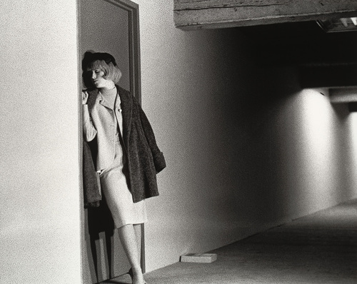
(Cindy Sherman, Untitled Film Still #4)

Description

In the last two hundred years, Europeans and Americans have frequently used the notion of alienation in conceiving of themselves. In fact, we might characterize these two centuries as a time in which, paradoxically enough, humans’ identity has been integrally linked with being, in some sense, ‘strange.’ The course will attempt to make sense of the many links and tensions between alienation and self-identity -- or strangeness and the self -- by examining strong voices in the development of the contemporary identity. While we will discuss all of the works in class, primary responsibility for composing a theory of the complex relationship between alienation and identity will rest upon the participants in the course. All written assignments will offer opportunities to articulate and develop those theories, as will class discussion and class presentations. The course will culminate in an examination of the artist Lucas Samaras for his modeling of the strange self.

Readings

Ralph Waldo Emerson, Divinity School Address and “Experience” (available on Canvas)
Friedrich Nietzsche, The Gay Science (Random, 1974) ISBN 0394719859 (selections, book to be purchased)
J.B. Pontalis, Love of Beginnings (selected chapters, available on Canvas)
Virginia Woolf, To the Lighthouse (Harvest, 1989) ISBN: 0156907399 (book to be purchased)

Schedule

Jan. 14 Introduction and Theory: Selves Pluralistic and Strange
The Common Sense Self of Mechanics, Medicine, and Technology
PowerPoint presentation: Selves in Art (Vermeer, Casper David Friedrich, Picasso, Cindy Sherman, Lucas Samaras, Edward Hopper, Chuck Close)

Jan. 21 Emerson, The Divinity School Address

Jan. 28 Emerson, “Experience”

Feb. 4 Nietzsche, The Gay Science
(paper #1 due)
Reading: sections 1-4, 11-14, 19, 21, 23, 38, 43, 46, 48, 54-56,
57-58

Feb. 11 Nietzsche, The Gay Science
Reading: sections 76, 107, 108-143, 276-285, 301, 340-41, 343-47, 370-71, 381-83

Feb. 18 Nietzsche
Readings: Any sections not completed in previous classes

Feb. 25 Woolf, To the Lighthouse
(paper #2 due)
Reading: pp. 3 – 124

March 11 Woolf, To the Lighthouse
Reading: pp. 125 – end

March 18 Woolf, To the Lighthouse

March 25 Pontalis
(paper #3 due)
Reading: Chapters 1 – 5

April 8 Pontalis
Reading: Chapters 6, 7

April 15 Pontalis
Reading: Chapters 10 – 12

April 22 Cindy Sherman (photos on Canvas)

April 29 Final Exam

Course Requirements
1. Class attendance
Presence at the first class meeting is strongly advised. Absences are not expected, though I do realize that most people in the course are working and unexpected work obligations may occur. More than one absence should be exceedingly rare.

2. All readings

3. Three papers (5 pages long), taking a position on the most definitive element in the nature of
the self, due after reading and discussing Emerson, Nietzsche, and Woolf

4. Final exam lasting two hours analyzing the photographs of Cindy Sherman for the “self” that
is evident in them and tracing connections to the selves discussed in class during the
semester. The final exam will be taken online, on the same day and time as the class.

Grading
Short papers: 50% of final grade for all
Class participation: 25% of final grade
Final Exam: 25% of final grade

Honor Code:
MALS and DLS students are responsible for upholding the Georgetown University Honor System and adhering to the academic standards included in the Honor Code Pledge stated below:
In the pursuit of the high ideals and rigorous standards of academic life, I commit myself to respect and uphold the Georgetown University Honor System: To be honest in any academic endeavor; and to conduct myself honorably, as a responsible member of the Georgetown community, as we live and work together.

Disabilities Statement:
If you believe you have a disability, then you should contact the Academic Resource Center (arc@georgetown.edu) for further information. The Center is located in the Leavey Center, Suite 335. The Academic Resource Center is the campus office responsible for reviewing documentation provided by students with disabilities and for determining reasonable accommodations in accordance with the Americans with Disabilities Act (ADA) and University policies.

e-mail: rufb@georgetown.edu
Office hours: Tuesdays 4:30 – 5:30

