Using Explore to Manage Courses
LOGIN to Explore using your NetID and password at: http://explore.georgetown.edu/
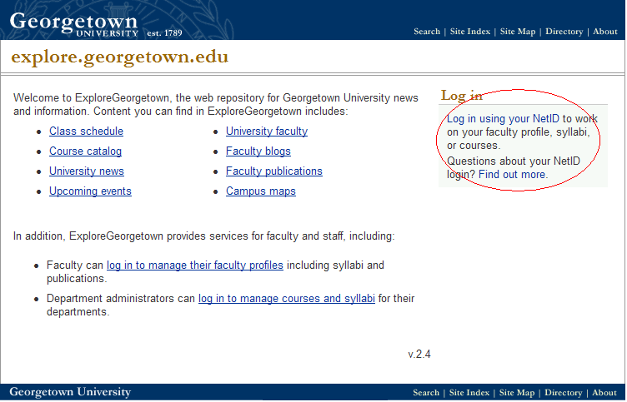

From your home page you will have the option to either update your own profile (your professional information and syllabi for courses you are teaching) or your departmental info (course descriptions, archive courses, reinstate retired courses, add courses, preview courses, and approve courses).

POSTING AND UPDATING SYLLABI
A course’s syllabus will appear in Explore in the course description area when you click on the faculty member’s name. It will also appear in the faculty profile through the directory if that faculty member posted a syllabus.
Click on YOUR PROFILE to add or change your own professional information and to post your syllabi.
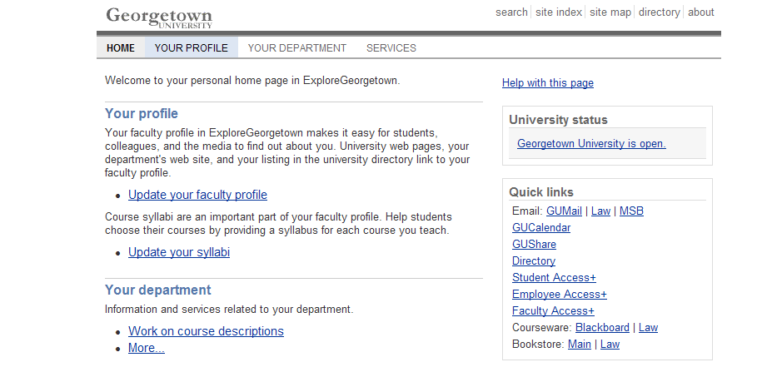

Click on Update your syllabi to post or change syllabi for your courses.
If you are logging in for the first time, click on Add materials for a course.
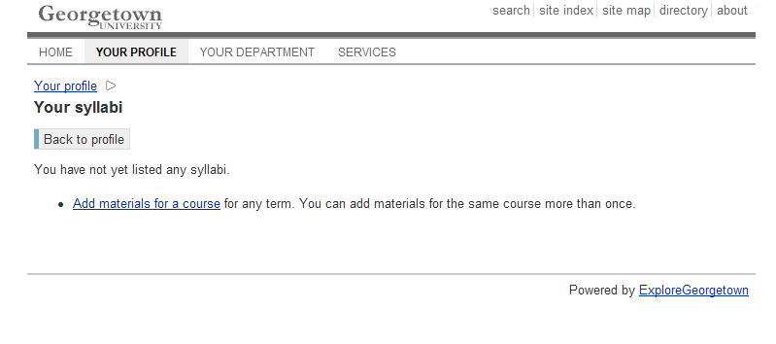
Use the drop down box to select the term for which you are posting a syllabus, then click Next step.
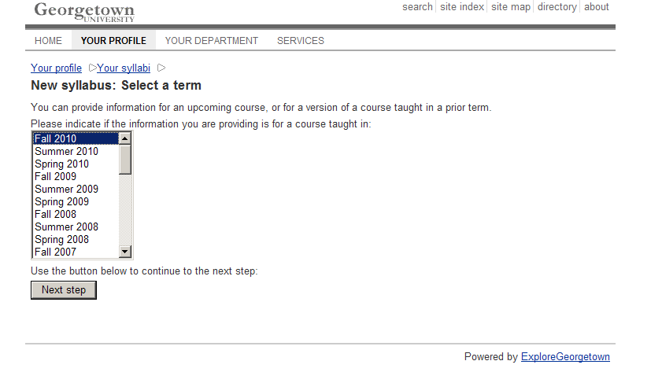
Use the drop down box to select your department, then click Next step.
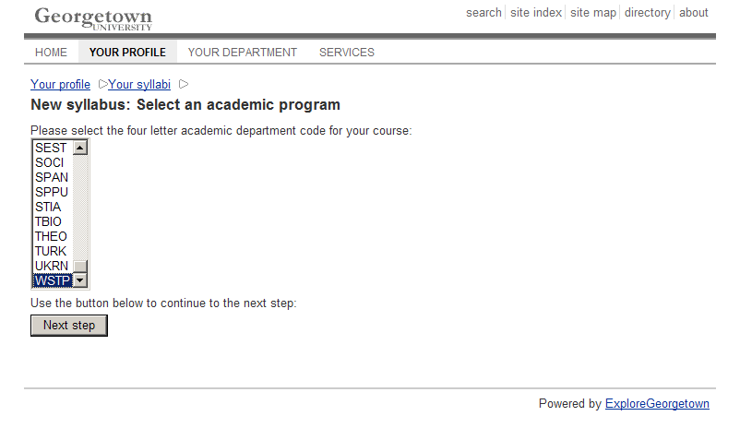
Use the drop down box to select the course for which you are posting a syllabus, then click Next step.
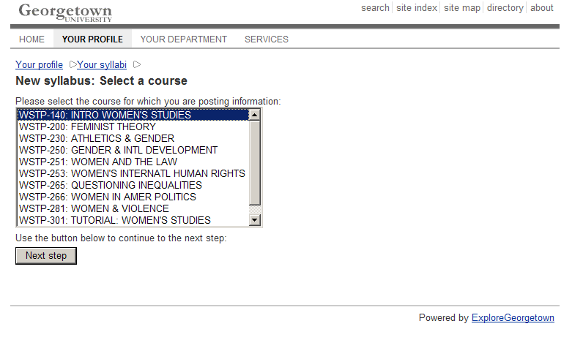
Use the drop down box to select the specific course section for which you are posting a syllabus (choose no specific section if the syllabus is the same for all sections), then click Next step.
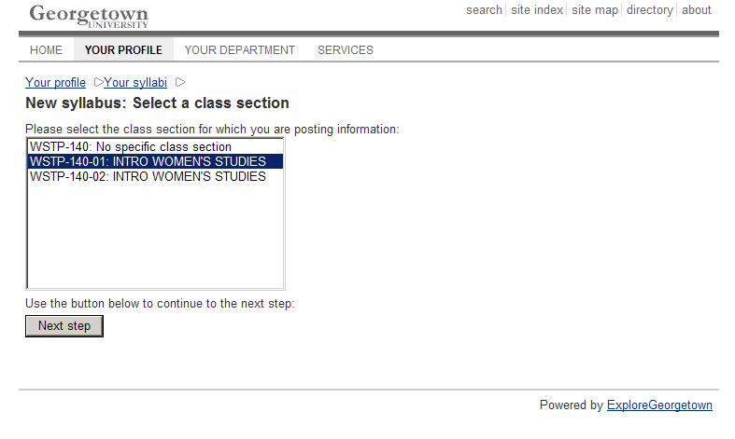
You can now add information about the course you would like prospective students to know, including: faculty who are teaching the course, a course website, brief course description, readings for the course, assignments and due dates, and other relevant information. You can also upload a syllabus if you have one saved already. When you are finished adding everything you want students to see, click Save.
You will automatically be brought to your profile page listing every course for which you have syllabi posted. You can view the changes you just made by clicking View under the appropriate course.
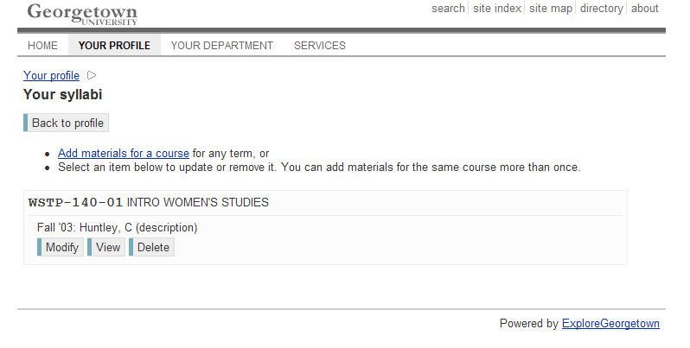
Your syllabus page will look something like this:
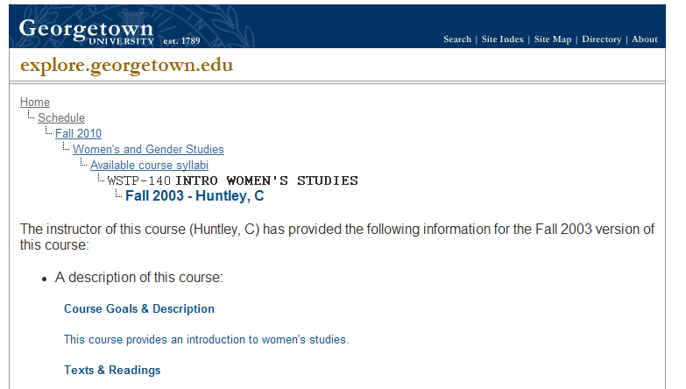
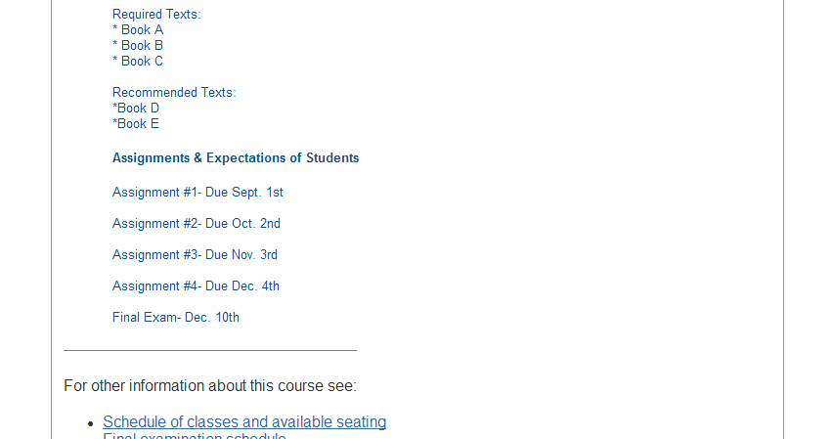

If this is not correct or you would like to make changes, you can go back to the list of syllabi by clicking your browser’s back button. You can then make changes by clicking Modify, or you can delete the syllabus completely by clicking Delete.
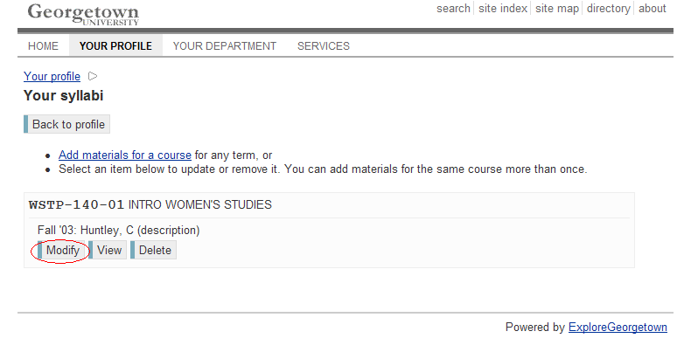

MANAGING YOUR COURSES & POSTING COURSE DESCRIPTIONS
Information posted here will appear in Explore when you browse courses in the course catalog.
In order to post a course description for a course, that course must exist in Explore.
Click on YOUR DEPARTMENT to browse retired courses, to add courses, to retire courses, to reinstate courses, to approve courses, and to preview courses.
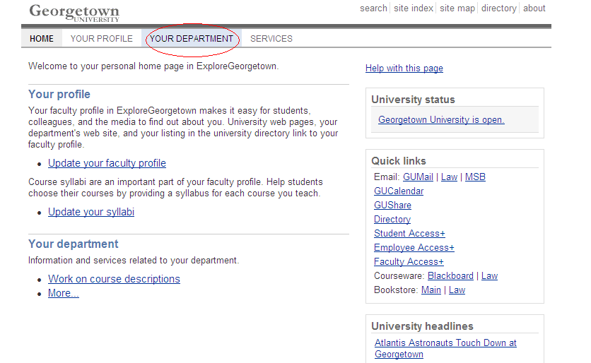
To manage your courses in Explore, click on your department name listed under the Courses and Syllabi section.
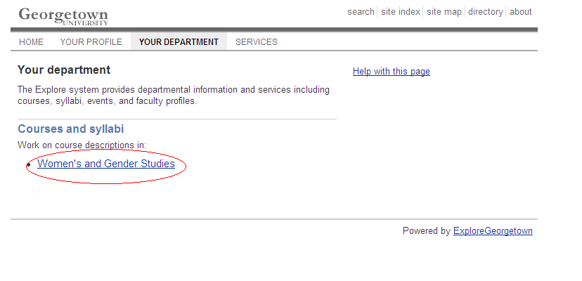
The Manage Courses menu should appear with all of the options below to help you manage your department’s courses and how they appear on Explore:
Browse archived courses – Click this to see a list of all courses that are no longer active in the course catalog.
Add a course – Click this to add a course into the Explore site, including the course description, faculty attached to the course, any pre-requisites for the course, and the terms in which the course is offered.
Retire a course – Click this to retire a course from the current academic year’s course catalog or to terminate it from all future course catalogs.
Reinstate retired courses – Click this to make a retired course active again in the current academic year’s course catalog.
Approve courses – Click this to approve courses that non-administrators in Explore have posted for your review and to add them to the current academic year’s course catalog.
Preview Courses – Click this to preview courses as they will appear on the Explore website for prospective and current students to see.

ADDING A COURSE
Click Add a course to begin adding a new course to Explore and complete all of the information you would like to appear on the Explore website. Any fields marked with a red * are required fields.
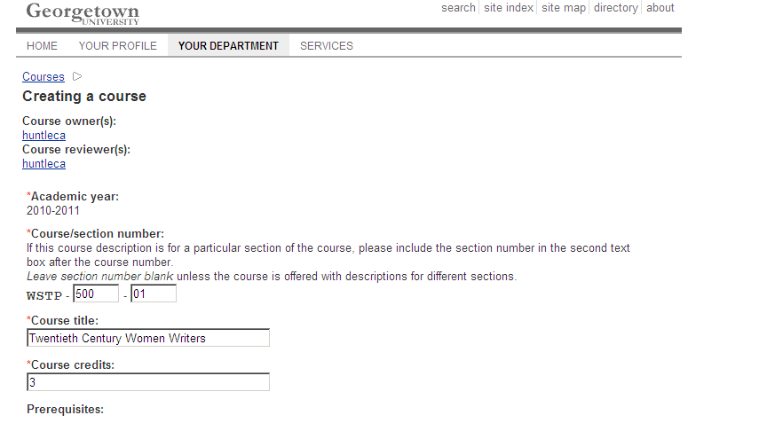
You must enter the Course number/ section here (ex: 500-01).
You must enter the Course title here (ex: Twentieth Century Women Writers).
You must enter the Course credits here (ex: 3).
If a pre-requisite exists for the course, you can enter it here as well (ex: WSTP-101-01).
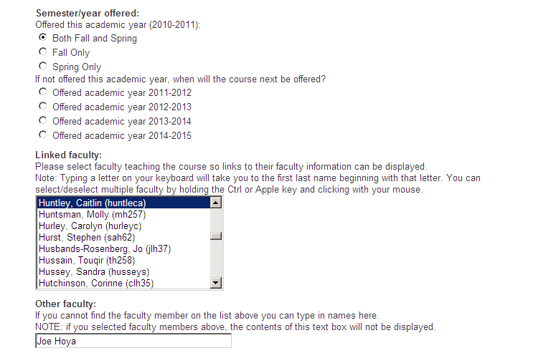
You will need to select the term and academic year that the course is offered. If the course is only offered in either the fall or the spring semester, select Fall Only or Spring Only, as appropriate. If the course is offered in any given semester or in the summer semester, select Both Fall and Spring.
You can also link a faculty member to the course here. Unless a faculty member is linked to the course, a syllabus will not be able to appear. If a faculty member posts information to his or her profile in Explore, such as a C.V. or personal website, that information will be linked to the faculty name linked to this course.
You can add a faculty member’s name in the box labeled Other faculty if you cannot find them in the list above.
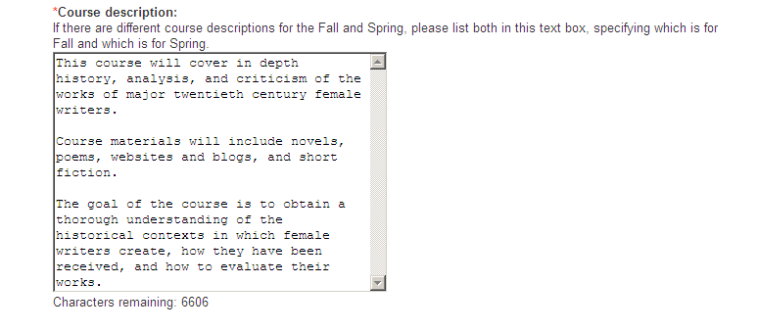
You must add a course description here. The course description should be general enough to apply to all sections of the course. If the course varies significantly in the fall and spring or summer semester, then you may enter more than one description in the text box, but you should label each description separately with the appropriate term in which it is offered. There is a 7000 character max.
Please note that this is not the space for entering specific course texts and assignments if they are not applicable to each section of the course in every term it is offered. Specifics can be noted in the syllabus section of the course, viewed through the faculty links.

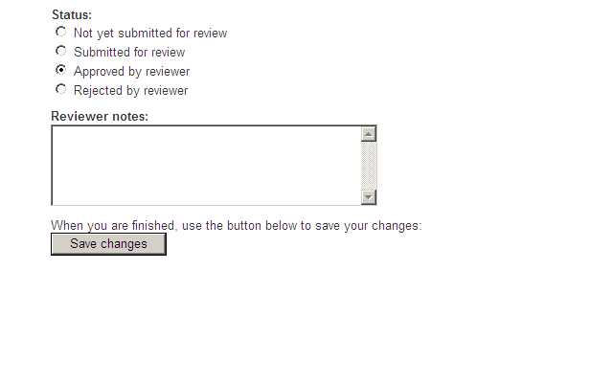
If you are an administrator, you can select Approved by reviewer to post the new course into your department’s course listings in Explore. The click Save changes to finish.
You will then see the following page as confirmation that your course has been added.
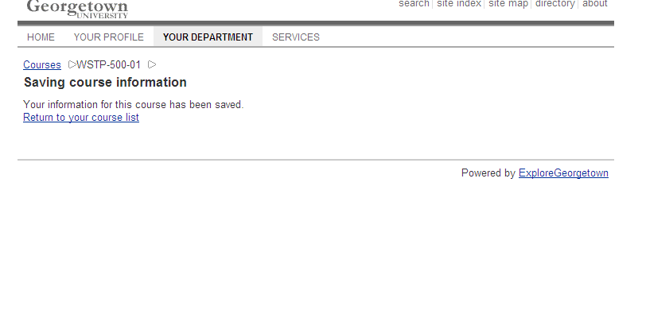
If you click Return to your course list, you will be able to see the full list of courses belonging to your department in Explore, including the course you just added.
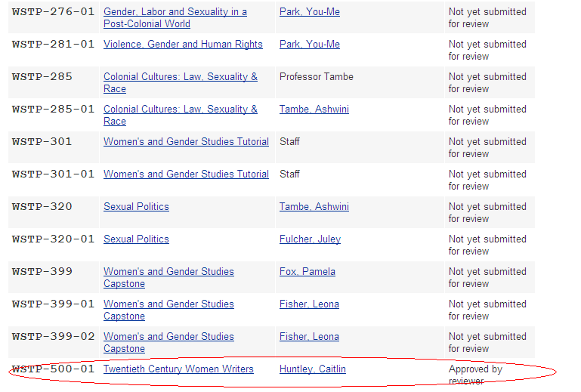

EDITING A COURSE
You may view and edit changes to the course you just added or to any other courses in your list by clicking on the course title.
When you click on a course title, you will see the course information as it will appear in Explore on the left in the blue box, and you can edit the information on the right if necessary.
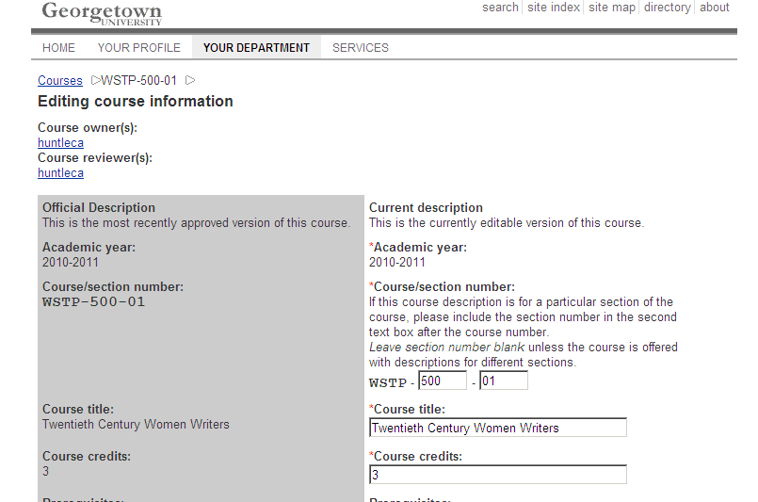
At the bottom of the blue box, you will see the history of the course management and status for the current academic year. *You can always return to the Manage courses page by clicking Courses at the top of the page.
If you made any changes to the course on the right, you must click Save changes at the bottom right.
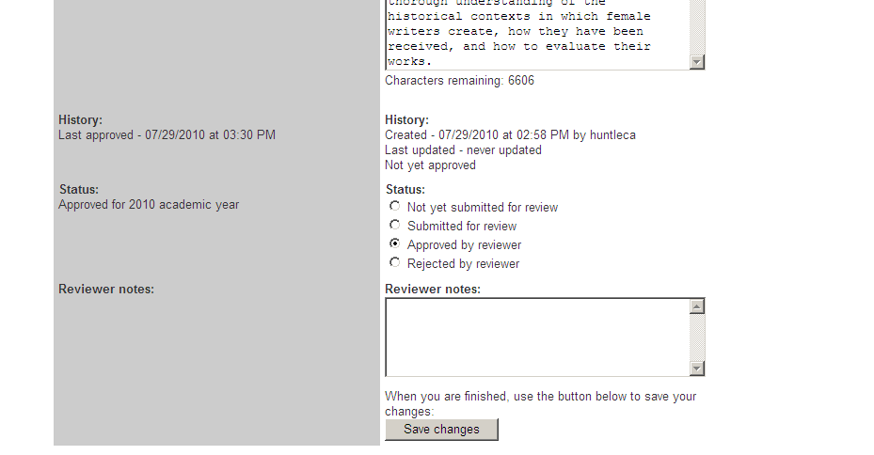

PREVIEWING A COURSE
Now that you have added your course or made the necessary changes to your course, you can see what it will look like to any prospective students who browse the online course catalog in Explore by clicking on Preview a course on the Manage courses page. 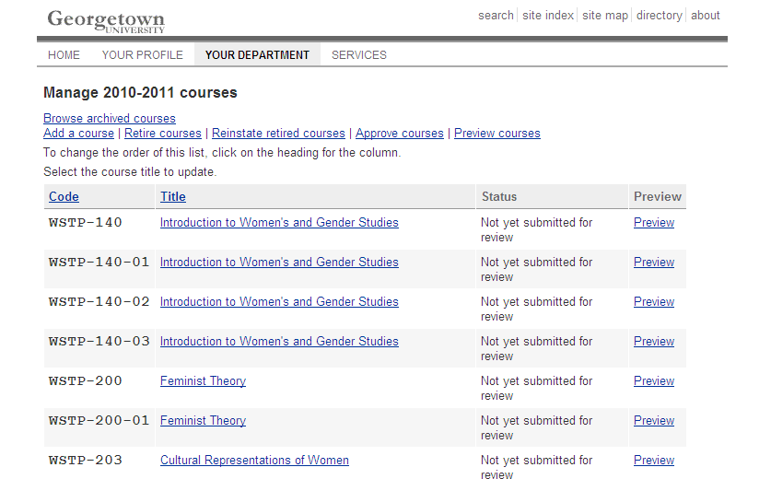
You must click Preview to see the course. (If you click on the course title, it will bring you to the course editing page again). Your course will appear in a new window:
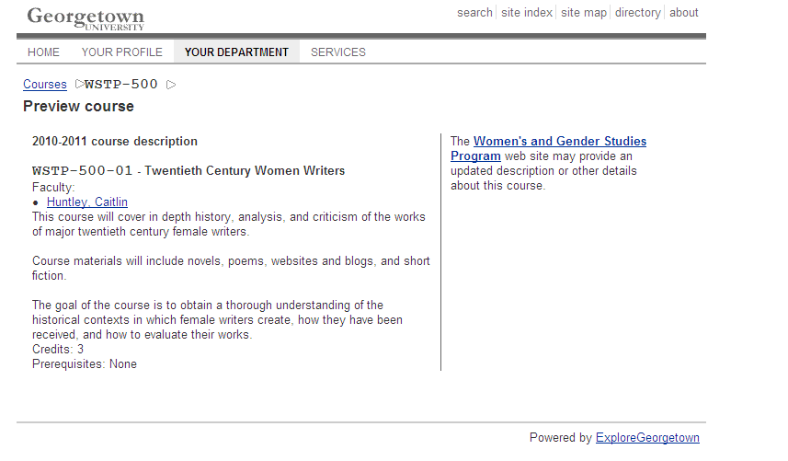

The remaining options in the Manage courses menu should only be used by an Explore administrator to retire courses, reinstate retired courses, or to approve courses submitted by non-administrators.

RETIRING A COURSE
You can retire a course for the current academic year or retire and terminate a course if it will never be offered again by clicking on Retire a course.
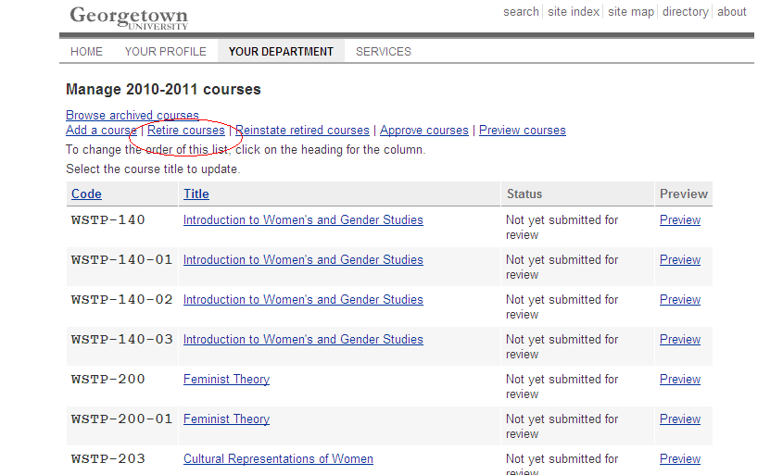
Simply click the Retire course box to the right of the course you would like to retire and then click Retire selected course.
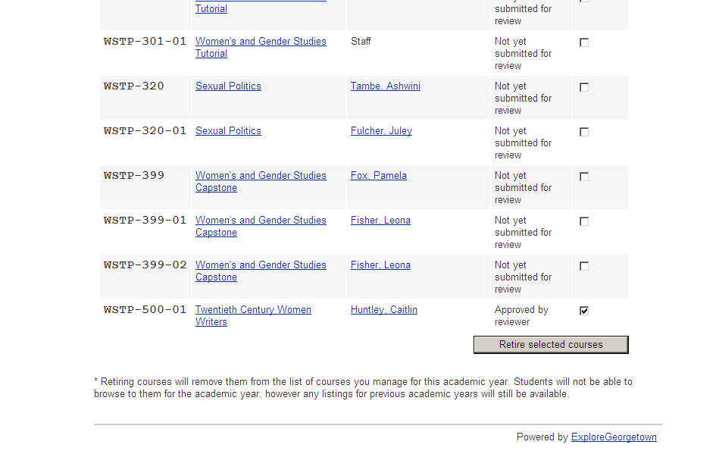
You will have the option to retire it for the current academic year or to retire it and terminate it. To retire the course from the course catalog but to maintain the option of reinstating again in the future, click the Retire only option. You should only select the Retire and terminate option if the course will not be offered again. Click Ok to finish retiring or retiring and terminating the course.
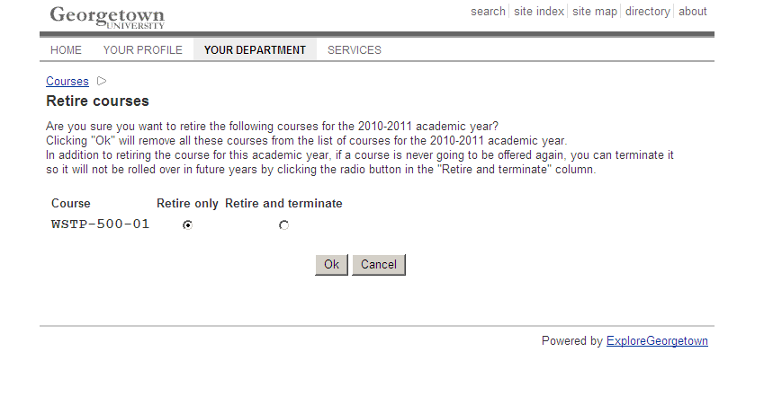

REINSTATING A COURSE
After you have retired a course, you will no longer see it in your list of courses in the Manage courses list. You can only view retired courses by clicking Reinstate retired courses on the Manage courses menu. Please note that if you retired and terminated a course, it will not appear in this list. If you need to reinstate a terminated course, you will have to add it as if it is a new course.
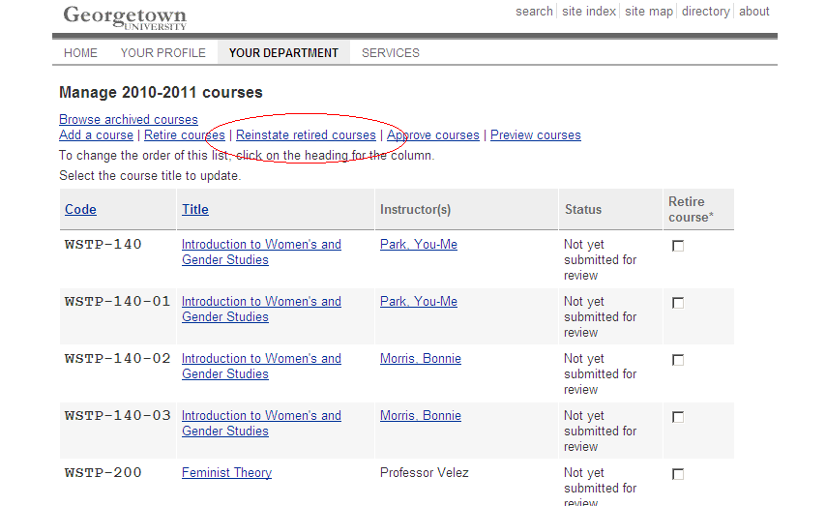

You may reinstate a retired course by simply clicking the Reinstate button to the right of the appropriate course and then clicking Reinstate selected course.
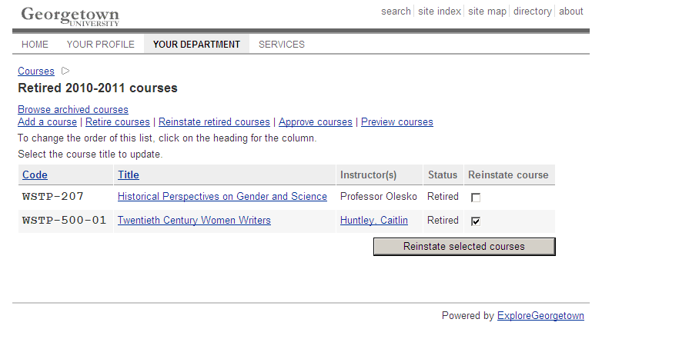
You will be asked if you are sure you want to reinstate the retired course. If you do not want to reinstate the course, click Cancel. If you would like to reinstate the course, click Ok.
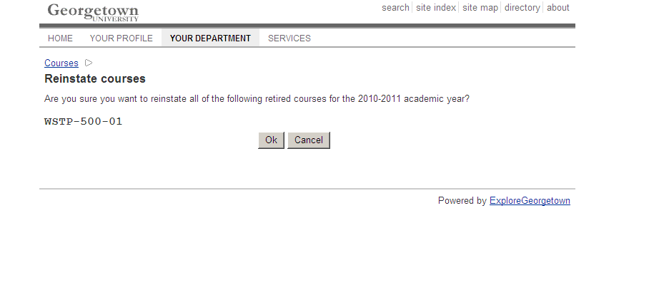
Once you reinstate a course it will appear again in your list of courses on the main Manage courses page. You may edit and preview you the same as other courses in your list.

